**First world countries:**

Andorra, Australia, Austria, Belgium, Bermuda, Brunei, Darussalam, Canada, Cyprus, Denmark, Finland, France, Germany, Greece, Hong Kong SAR, China, Iceland, Ireland, Israel, Italy, Japan, Korea, Rep, Kuwait, Liechtenstein, Luxembourg, Macao SAR, China, Malta, Monaco, Netherlands, New Zealand, Norway, Oman, Portugal, Qatar, San Marino, Saudi Arabia, Singapore, Spain, Sweden, Switzerland, Taiwan, China, United Arab Emirates, United Kingdom, & United States.

**Second World countries:**

Albania, Algeria, Argentina, Armenia, Azerbaijan, Belarus, Belize, Bosnia and Herzegovina, Botswana, Brazil, Bulgaria, Chile, China, Colombia, Costa Rica, Croatia, Cuba, Dominica, Dominican Republic, Ecuador, Egypt, Arab Rep., El Salvador, Equatorial Guinea, Eswatini, Fiji, Gabon, Georgia, Grenada, Guatemala, Guyana, Iran, Islamic Rep., Iraq, Jamaica, Jordan, Kazakhstan, Lebanon, Libya, Malaysia, Maldives, Mauritius, Mexico, Moldova, Montenegro, Morocco, Namibia, North Macedonia, Panama, Paraguay, Peru, Philippines, Romania, Russian Federation, Saint Lucia, Saint Vincent and the Grenadines, Samoa, Serbia, South Africa, Sri Lanka, Suriname, Thailand, Timor-Leste, Tonga, Tunisia, Turkey, Turkmenistan, Ukraine, Uruguay, & Venezuela, RB.

**Third World countries:**

Afghanistan, Benin, Burkina Faso, Burundi, Cambodia, Central African Republic, Chad, Comoros, Congo, Dem. Rep., Congo, Rep., Cote d'Ivoire, Djibouti, Eritrea, Ethiopia, Gambia, The, Ghana, Guinea, Guinea-Bissau, Haiti, Kenya, Korea, Dem. People's Rep., Kyrgyz Republic, Lao PDR, Lesotho, Liberia, Madagascar, Malawi, Mali, Mauritania, Mozambique, Myanmar, Nepal, Niger, Nigeria, Pakistan, Papua New Guinea, Rwanda, Sao Tome and Principe, Senegal, Sierra Leone, Solomon Islands, Somalia, South Sudan, Sudan, Syrian Arab Republic, Tanzania, Togo, Uganda, Uzbekistan, Vanuatu, Yemen, Rep., & Zambia.

**Fourth World:**

* Indigenous peoples and other marginalized groups, who are frequently excluded from mainstream culture and who lack political clout, financial resources, and social recognition, are referred to as being in the "Fourth World." These communities frequently have unique cultural practices, dialects, and customs, and they may be spread across numerous nations or be part of bigger nation-states.

Anthropologist Michael Coe first proposed the idea of the Fourth World in the 1970s, claiming that these societies faced a specific set of issues that necessitated special care and assistance. Since then, the phrase has been used by activists, academics, and policymakers to promote the rights and welfare of these people and to draw attention to the ways in which colonialism, globalization, and other forces of modernization have neglected and mistreated them.

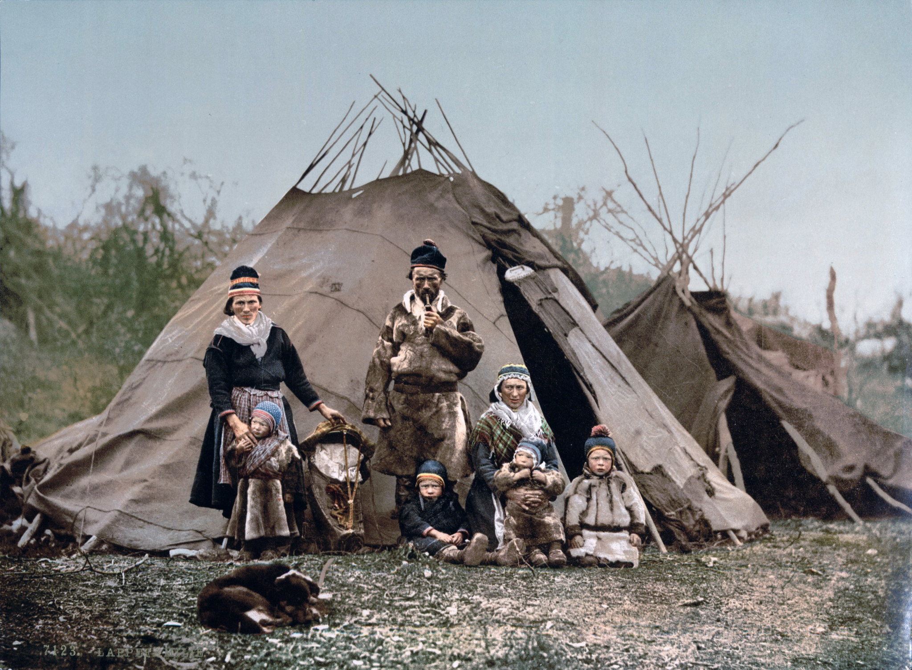

*An example of a Fourth World community is the Sami people, who are an indigenous group that inhabits the northern regions of Scandinavia, Finland, and Russia. The Sami people have a distinct culture and language, and historically, they have relied on reindeer herding and fishing as their primary means of subsistence.*